AWS TASK -3

Create a S3 bucket, with no public access and upload files to the bucket & view the logs using cloudwatch for the uploaded files.

**Step 1: Create S3 bucket with no public access**

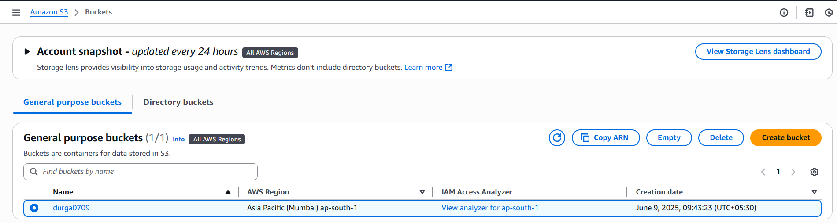

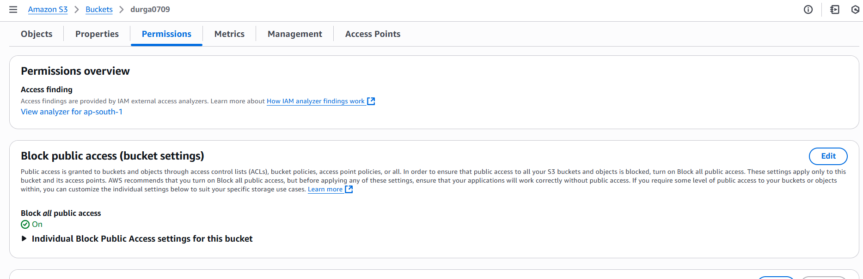

**Step 2: Enabling Access logging for monitor logs in Cloud watch**

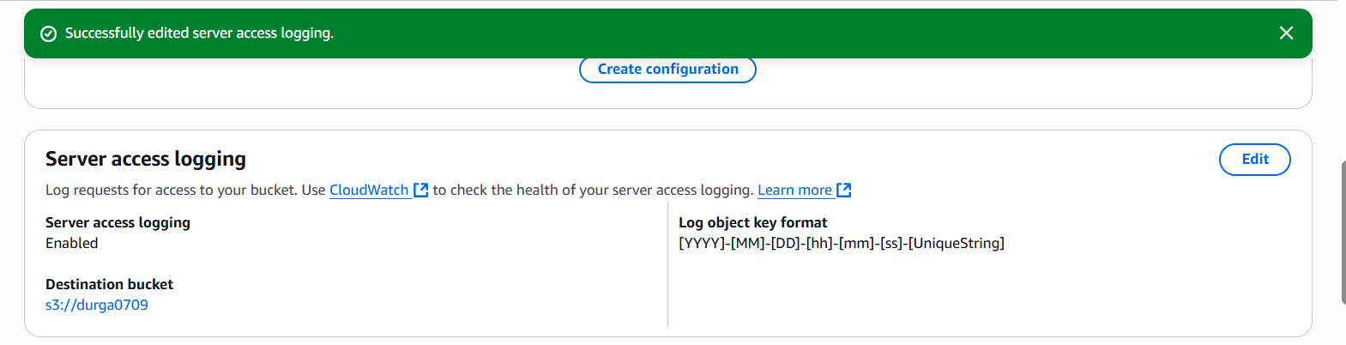

**Step 3: Upload files to the bucket**  
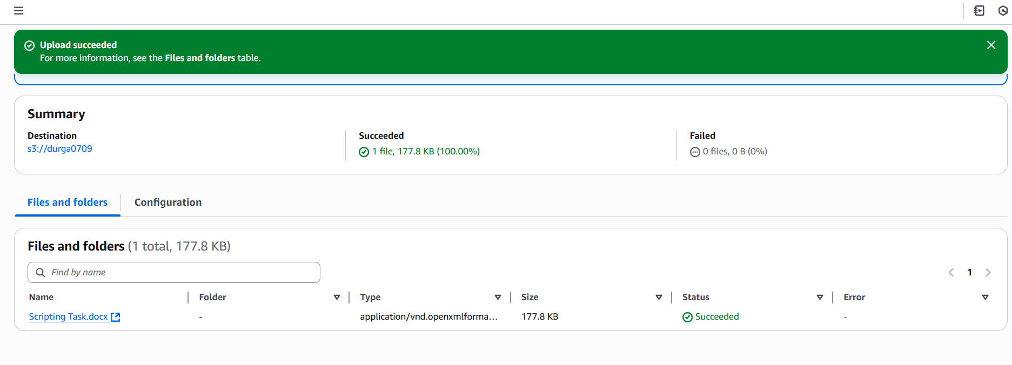

**View logs in CloudWatch**

step 1:Create new Trail

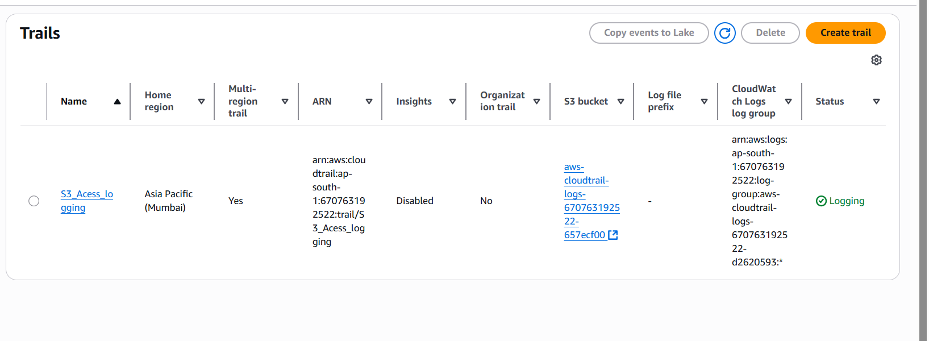

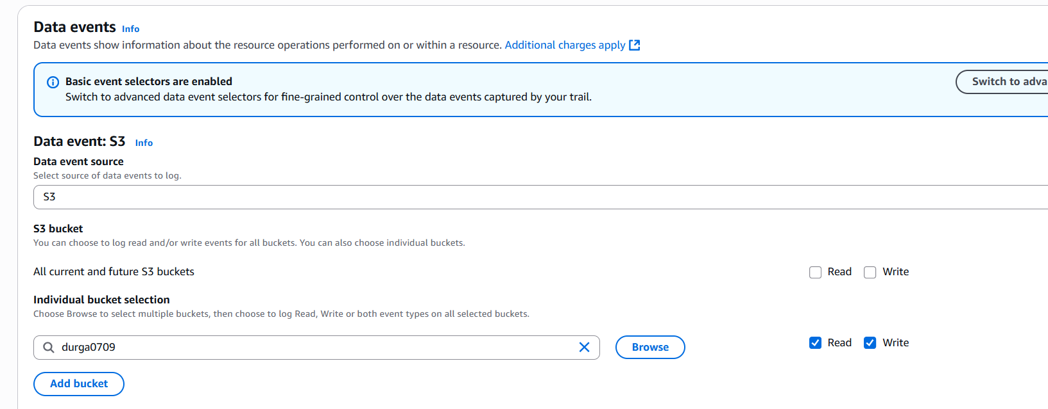

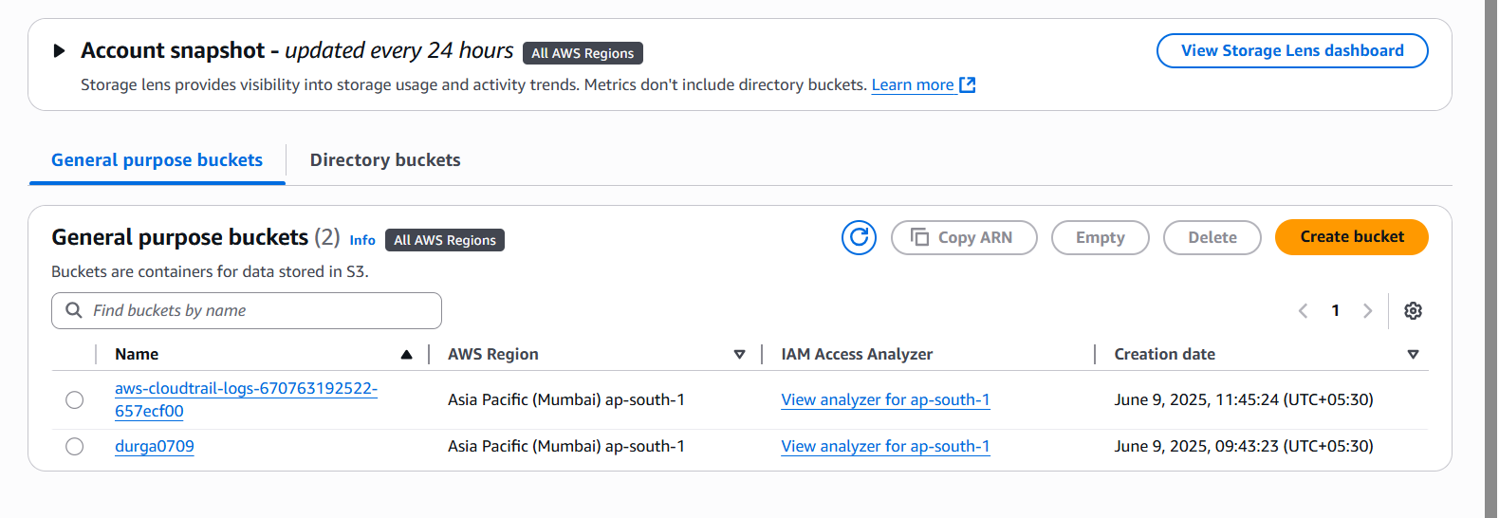

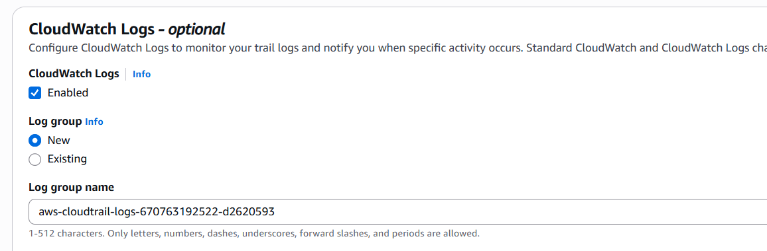

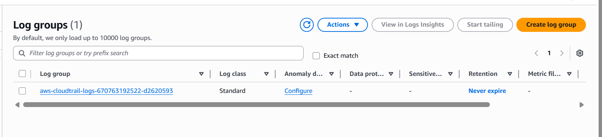

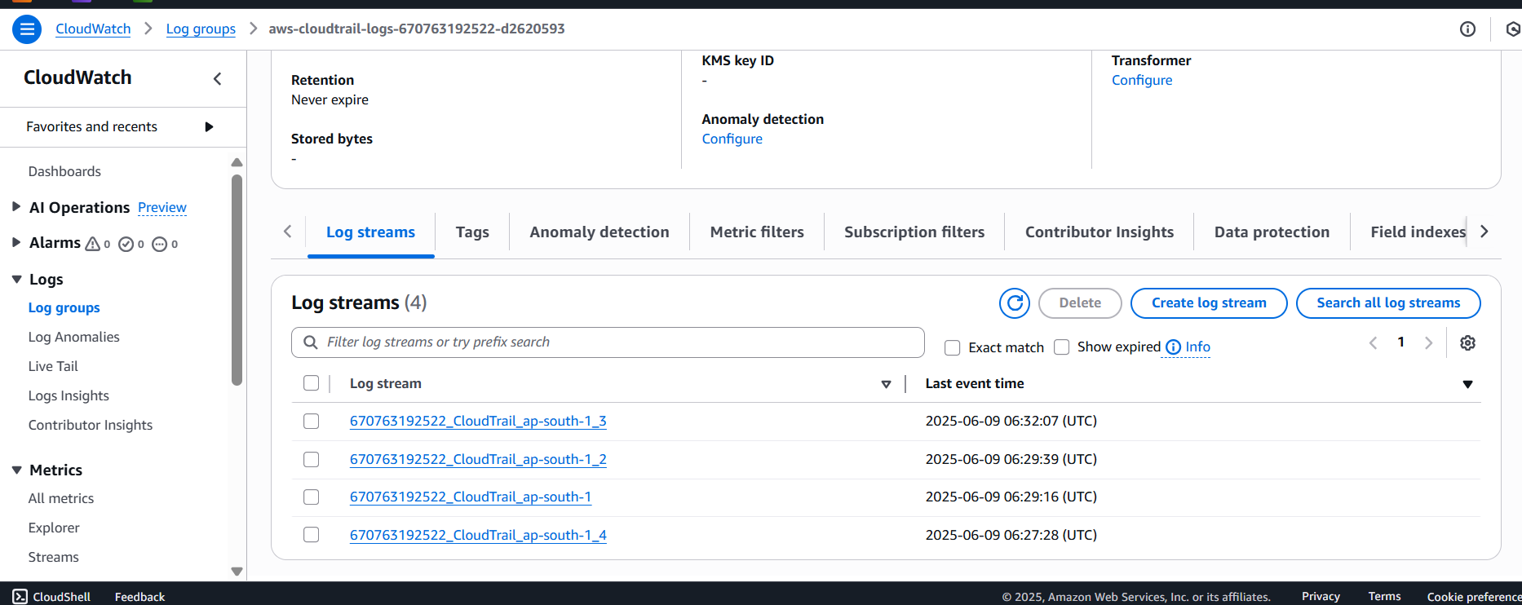

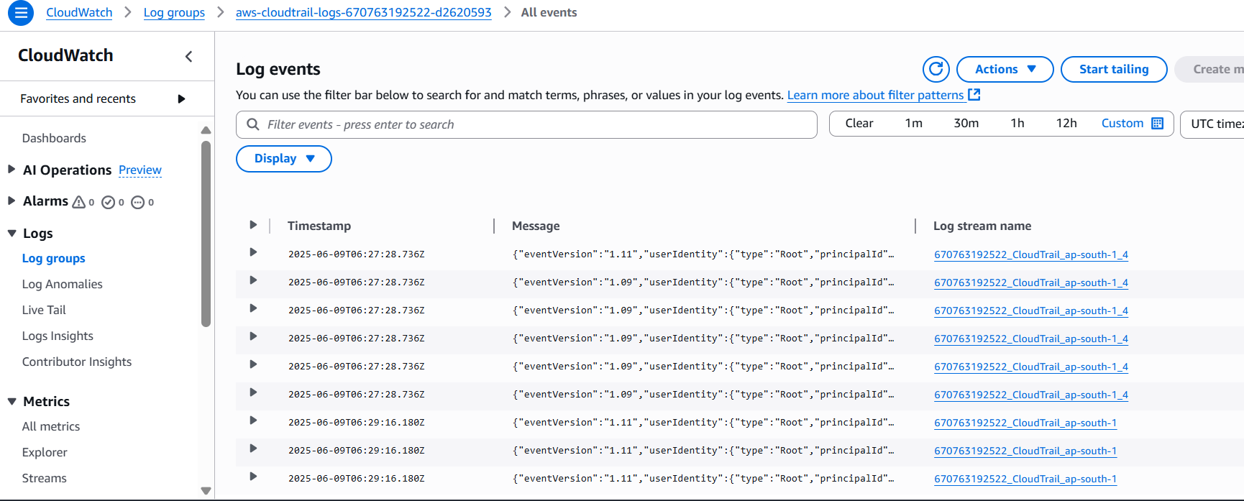

**2.Launch two ec2-instances and connect it to a application load balancer, where the output traffic from the server must be an load balancer IP address**

Step 1: **Create two EC2 instance**

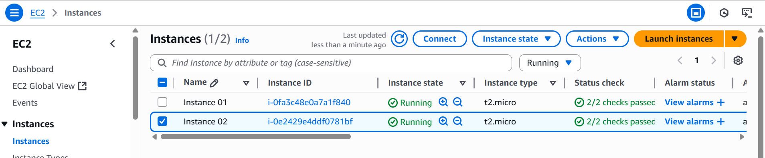

**Create simple html page for test the DNS server**

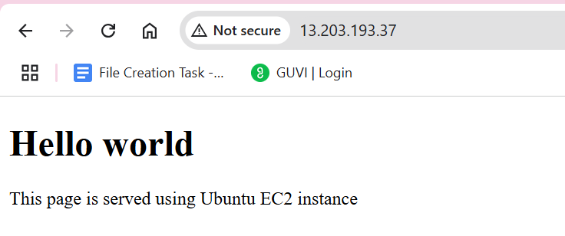

Step 2: **Create target group**

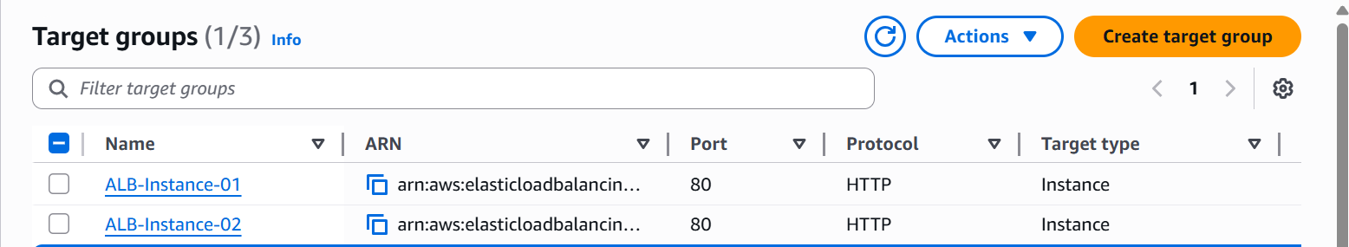

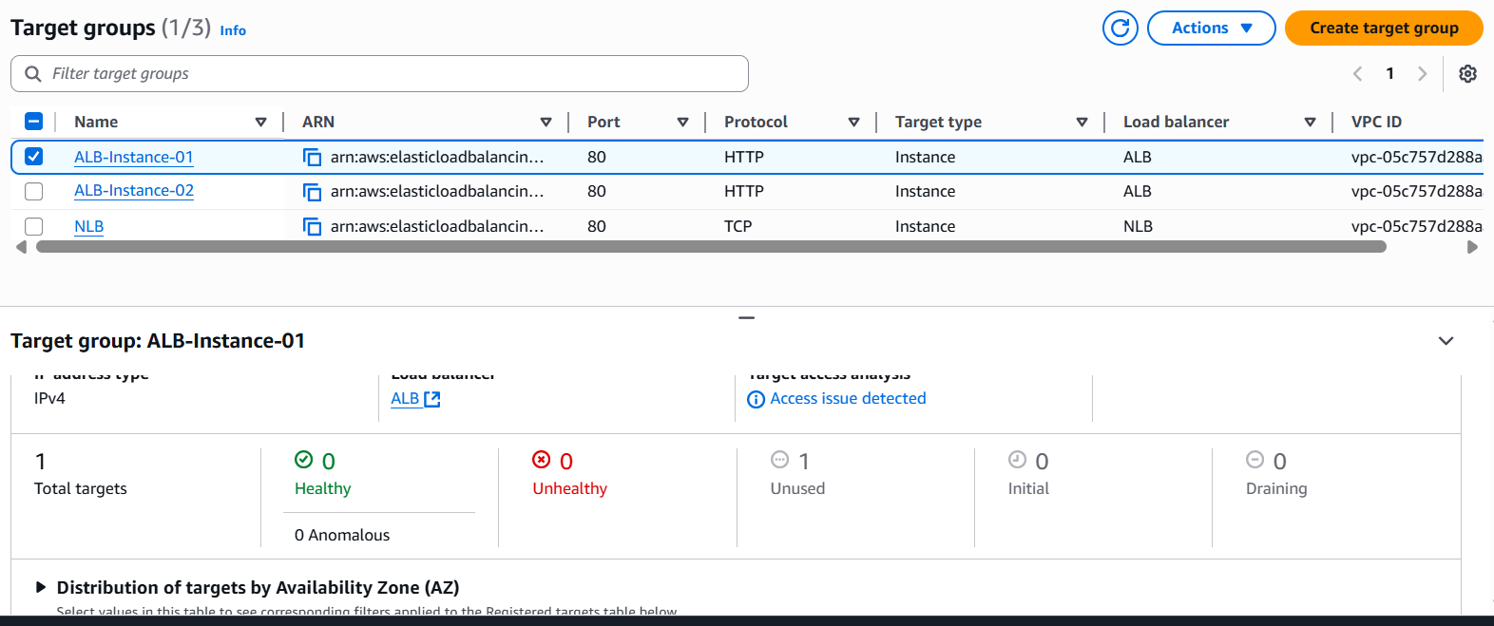

Step 3**: Create application load balancer**

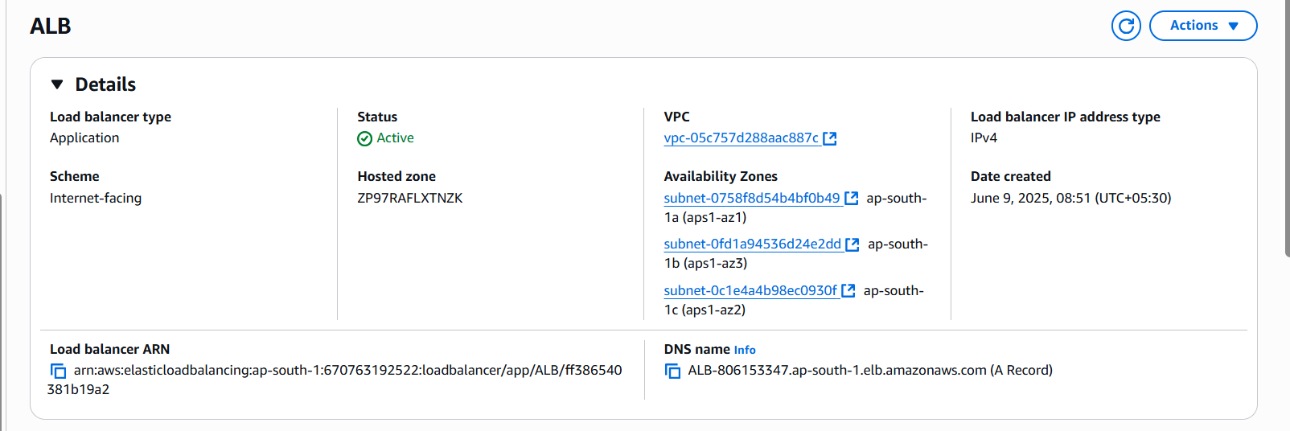

**Test Application Load Balancer(ALB)**

